Email 1a: Campaign Kick-off from United Way
From: Your United Way CEO/CPO, Board or Campaign Chair’s first and last name
Audience: All company employees
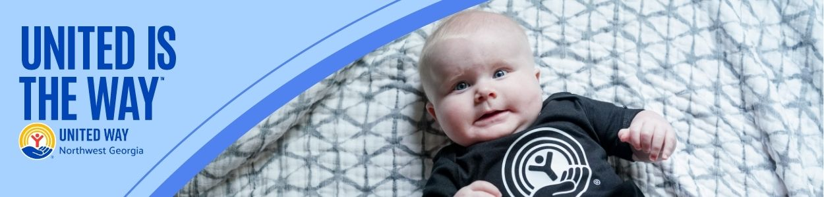
Subject Line: United is the Way to change lives in Northwest Georgia
Email Body:
[NAME],
Today, so many of our neighbors in Whitfield and Murray counties are working hard to overcome barriers and get ahead.
Somewhere in our community:
- A working parent is looking for a way to make this week’s paycheck cover the growing costs of groceries, prescriptions, and housing.
- A middle-schooler is struggling to find a way to stay focused in class because she didn’t get a nutritious breakfast this morning.
- A recent high school graduate is eager to turn his diploma into a promising career and a stable future.
But they’re not alone.
Together with our community-serving partners and supporters like you, we can connect people to the opportunities they need to reach their full potential and make Whitfield and Murray counties a place where everyone can thrive.
Donate today and join us in creating more thriving communities for all. No challenge is too big for us to take on if we work together.
Because, United is the Way™.
BUTTON TEXT: Give Today [Hyperlink to donation page]
Sincerely,
[NAME]

