**Email 2:** Our Value-Add  
**From:** Your United Way CEO/CPO, Board or Campaign Chair’s first and last name **Audience:** All company employees

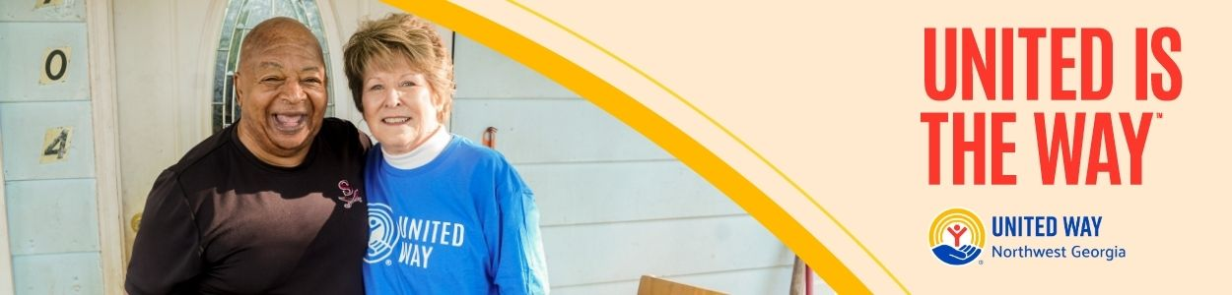

**Subject Line: What makes change in Northwest Georgia possible? People like you!**   
**Email Body:**

[NAME],

For over 80 years, United Way of Northwest Georgia has focused on harnessing the caring power of our community to help ensure that everyone can thrive. While the needs in Whitfield and Murray counties are great, and the challenges are sometimes daunting, we at United Way have the privilege of seeing the very best that our community is capable of.

There’s nothing more powerful than a group of people united to do good. Last year alone, with the help of partners, volunteers, and donors like you, United Way of Northwest Georgia was able to:

* **Youth Opportunity** – Empower 3,844 young people through career education, leadership development, and workforce training, preparing them for lifelong success.
* **Financial Security** – Provide food assistance to 17,028 individuals, along with vital financial education and stability resources.
* **Healthy Community** – Deliver character education to 8,982 youth, encouraging healthy choices and positive behaviors.
* **Community Resiliency** – Connect 66,637 neighbors to critical resources, hope, and support through our 211 helpline.

And we’re not stopping there. Your support can help us continue tackling the biggest problems in Whitfield and Murray counties. No challenge is too big for us to take on if we work together. Because when people unite to take action, transformational change is possible.

**United is the Way™.**

Give today and join us in creating more thriving communities for all.

BUTTON TEXT: Give Today [Hyperlink to donation page]

Sincerely,

[NAME]