Email 3a: First Reminder – United Way’s Impact
From: Your United Way CEO/CPO, Board or Campaign Chair’s first and last name Audience: All company employees
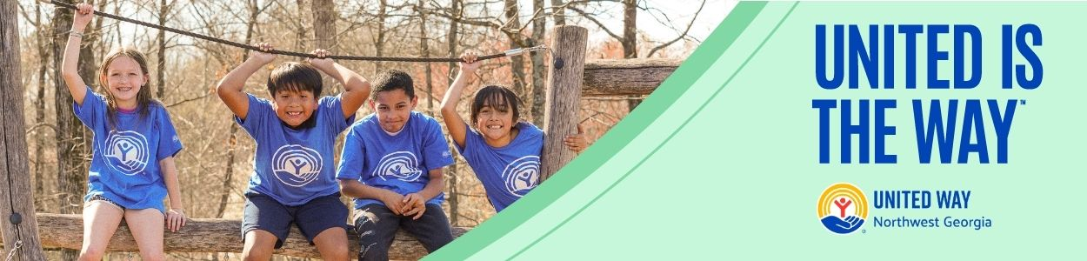
Subject Line: What is United Way doing for the Northwest Georgia community?
[NAME],
Whether you’re new to United Way of Northwest Georgia or you’ve been creating impact with us for years, we want you to consider yourself part of our caring community of hand-raisers, problem-solvers, and changemakers.
At United Way, we believe that everyone who lives and works in Whitfield and Murray County deserves the opportunity to thrive. Together with you and all our partners at [COMPANY NAME], United Way mobilizes the caring power of everyday people to create transformational change here in Northwest Georgia.
Day in and day out, United Way of Northwest Georgia funds, supports, leads, and develops programs that meet the most urgent needs in our community. We’re proud of all we’ve accomplished together on behalf of the individuals and families that call Whitfield and Murray County home.
Dustin’s Journey:
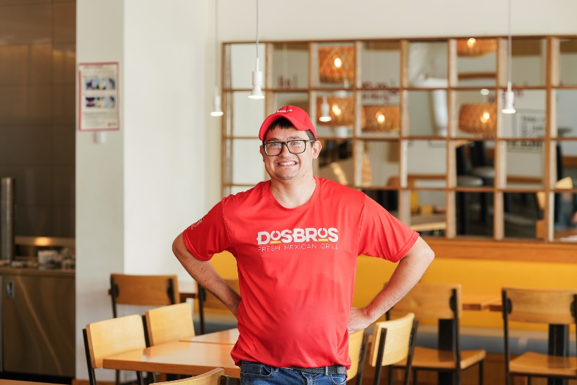
Diagnosed with a developmental disability early in life, Dustin struggled to find meaningful work until he connected with CrossPlains Community Partner, a United Way-funded partner. With the support of his job coach and community-based services, he built confidence, gained real-world skills, and found success at Dos Bros Mexican Grill. Today, he’s a valued employee, mentors others, and lives more independently. “I never thought I could do all this,” Dustin shares. “But now I know I can. I feel proud of who I am.” His story shows what’s possible when we invest in people. When you give to United Way of Northwest Georgia, you help turn barriers into opportunities and dreams into reality.
If you’ve already made a one-time or recurring gift this year, thank you for being part of our community-led movement for good. If you haven’t, we hope you’ll consider giving by the [DATE] campaign deadline.
A better future is possible when we work together to achieve it. United is the Way™ we can make Whitfield and Murray counties a community where everyone has the chance to thrive.
BUTTON TEXT: Give Today [Hyperlink to donation page]
Sincerely,
[NAME]

