**Email 3b:** Second Reminder – Our Shared Impact  
**From:** Your United Way CEO/CPO, Board or Campaign Chair’s first and last name **Audience:** All company employees

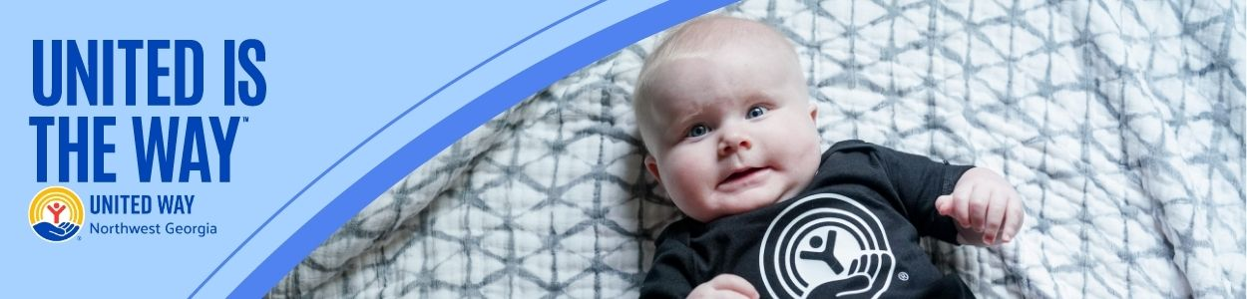

**Subject Line: United Way and [COMPANY NAME] are uniting to change lives**

[NAME],

We want to take a moment to celebrate how United Way of Northwest Georgia and [COMPANY NAME] are partnering to change lives in our community.

Thanks to [COMPANY NAME]’s leadership, and supporters like you…

[This email should be tailored to your relationship with the company. We suggest:

* Highlight the number of years the company has been partnering with your United Way
* Highlight the impact the company has had during your Make a Difference Day events and the value of employee volunteerism to your community. Add photos, if you have releases.
* Highlight company involvement through all United Way events
* Does the company have a number of hours of volunteerism to celebrate?]

Let’s build on [COMPANY NAME]’s legacy to do even more. Join us in creating more thriving communities for all. **United is the Way™ we can make Whitfield and Murray counties communities where everyone has the chance to thrive.**

BUTTON TEXT: Give Today [Hyperlink to donation page]

Sincerely,

[NAME]